CRUCISPORT

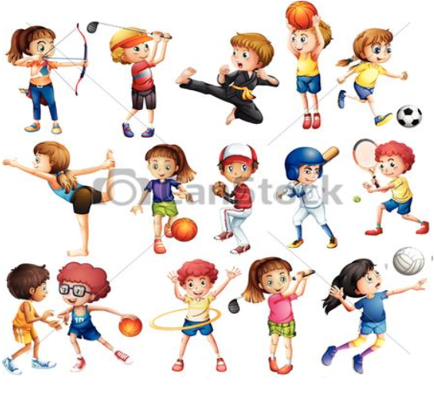
P | O | I | G | G | A | N | I | T | T | A | P | O
I | I | T | T | H | O | A | T | Y | F | F | O | L
S | T | C | O | L | J | L | C | L | Z | M | C | O
S | E | A | S | U | R | F | F | I | S | C | A | V
Z | N | N | D | A | N | Z | A | I | P | B | L | A
S | N | O | N | A | M | A | L | L | A | P | C | L
C | I | T | W | A | T | C | L | S | E | I | I | L
H | S | T | E | B | I | E | E | L | T | V | O | A
E | K | A | I | C | O | B | K | E | A | D | B | P
R | U | G | B | Y | A | A | L | S | R | P | O | U
M | B | G | S | L | U | T | R | Z | A | Y | C | B
A | R | I | L | F | A | R | P | D | K | B | C | U
M | F | O | M | S | I | N | I | P | L | A | E | S

